Year 1 / 2 Overview for 2022-2023
 | 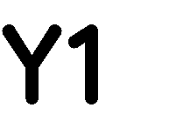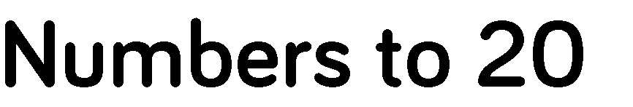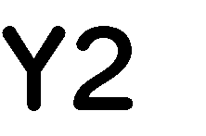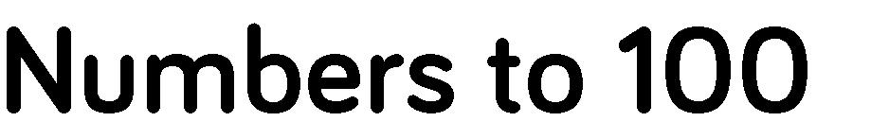 |  |  | 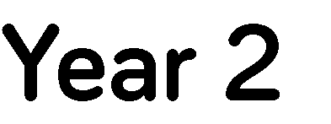
 | 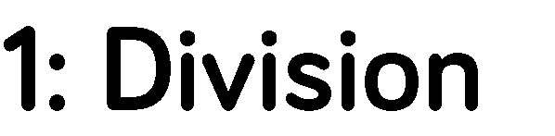
 |  |  | 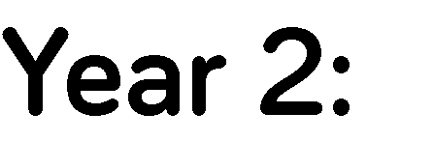
 |  |  |  |  |  | 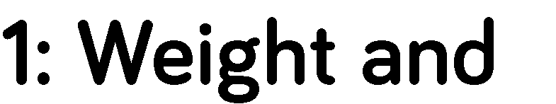

Mathematics Year 1 | Maths 2021-2022 (adapted for cohort)
 | Autumn 1 | Autumn 2 | Spring 1 | Spring 2 | Summer 1 | Summer 2
 | Number: Place Value  • Sort objects.  • Count objects.  • Represent objects.  • Count, read & write forwards from any number 0 -10.  • Count, read & write backwards from any number 0- 10.  • Count one more.  • Count one less.  • One to one correspondence to start to compare groups.  • Compare groups using language such as equal,  more/greater, less/fewer.  • Introduce = , > and < symbols.  • Compare numbers.  • Order groups of objects.  • Order numbers.  • Ordinal numbers (1st, 2nd, 3rd ….).  • The number line  .Number: Addition and Subtraction  • Part whole model.  • Addition symbol.  • Fact families – Addition facts.  • Find number bonds for numbers within 10.  • Systematic methods for number bonds within 10.  • Number bonds to 10.  • Compare number bonds. | Number:Addition and Subtraction  • Addition: Adding together.  • Addition: Adding more.  • Finding a part.  • Subtraction: Taking away, how many left? Crossing out.  • Subtraction: Taking away, how many left? Introducing the  subtraction symbol.  • Subtraction: Finding a part, breaking apart.  • Fact families – 8 facts.  • Subtraction: Counting back.  • Comparing addition and subtraction statements a + b > c.  • Comparing addition and subtraction statements a + b > c + d.  Number: Place Value  • Count forwards and backwards and write numbers  to 20 in numerals and words.  • Numbers from 11 to 20.  • Tens and ones.  • Count one more and one less.  • Compare groups of objects.  • Compare numbers.  • Order groups of objects.  • Order numbers. | Consolidation  Geometry  • Recognise & name 3D shapes.  • Sort 3D shapes.  • Recognise & name 2D shapes.  • Sort 2D shapes.  • Patterns with 3D & 2D shapes  Number:Addition and Subtraction  • Add by counting on.  • Find and make number bonds.  • Add by making 10.  • Subtraction: Finding the difference.  • Subtraction – Not crossing 10.  • Subtraction – Crossing 10 (1).  • Subtraction – Crossing 10 (2).  • Related Facts.  • Compare Number Sentences  Place Value: • Numbers to 50.  • Tens and ones.  • Represent numbers to 50. | Place Value:  • One more one less.  • Compare objects within 50.  • Compare numbers within 50.  • Order numbers within 50.  • Count in 2s.  • Count in 5s  Number: Fractions  • Halving shapes or objects.  • Halving a quantity.  • Find a quarter of a shape or object.  • Find a quarter of a quantity.  Geometry  • Describe turns.  • Describe Position (1).  • Describe Position  (2). | Time  • Before and after.  • Dates.  • Time to the hour.  • Time to the half hour.  • Writing time.  • Comparing time  Place Value  • Counting to 100.  • Partitioning numbers.  • Comparing numbers (1).  • Comparing numbers (2).  • Ordering numbers.  • One more, one less.  Number: Multiplication and (including multiples of 2, 5 and 10)  • Count in 10s.  • Make equal groups.  • Add equal groups. | Number: Multiplication and (including multiples of 2, 5 and 10)  • Make arrays.  • Make doubles.  • Make equal groups – grouping.  • Make equal groups – sharing.  Money  • Recognising coins.  • Recognising notes.  • Counting in coins.  Measurement:  Weight and Volume  Length and Height
Mathematics Year 2 | Number: Place Value  • Count forwards & backwards within 20  • Tens and ones within 20  • Count forwards & backwards within 50  • Tens and ones within 50  • Compare numbers within 50  • Count objects to 100 and read and write  • numbers in numerals and words.  • Represent numbers to 100.  • Tens and ones with a part whole model.  • Tens and ones using addition.  • Use a place value chart.  • Compare objects.  • Compare numbers.  • Order objects and numbers.  • Count in 2s  • Count in 5s & 10s  • Count in 3s  Number: Addition and Subtraction  • Fact families – Addition and subtraction bonds to 20.  • Check calculations.  • Compare number sentences.  • Related facts.  • Bonds to 100 (tens).  • Add and subtract 1s. | Number: Addition and Subtraction  • 10 more and 10 less.  • Add and subtract 10s.  • Add by making 10  • Add a 2-digit and 1-digit number – crossing 10.  • Subtraction – crossing 10  • Subtract a 1-digit number from a 2-digit number – crossing 10.  • Add two 2-digit numbers – not crossing 10 – add ones and add tens.  • Add two 2-digit numbers – crossing 10 – add ones and add tens.  • Find and make number bonds  • Bonds to 100 (tens and ones).  • Add three 1-digit numbers.  Consolidation | Measurement:  Money  • Recognising coins & notes  • Count money – pence.  • Count money – pounds (notes and  coins).  • Count money – notes and coins.  • Select money.  • Make the same amount.  • Compare money.  • Find the total  Number:  Multiplication and Division  • Recognise equal groups.  • Make equal groups.  • Add equal groups.  • Multiplication sentences using the x symbol.  • Multiplication sentences from pictures.  • Use arrays.  • 2 times-table.  • 5 times-table.  • 10 times-table.  • Make equal groups – sharing.  • Make equal groups – grouping.  • Divide by 2.  • Odd and even numbers.  • Divide by 5.  • Divide by 10. | Number: Addition and Subtraction  • Subtract a 2-digit number from a 2-digit number – not crossing 10.  • Subtract a 2-digit number from a 2-digit number – crossing 10 – subtract ones and tens.  Measurement:  Money  • Find the difference.  • Find change.  • Two-step problems.  Geometry: Properties of Shape  • Recognise 2D and 3D shapes.  • Count sides on 2D shapes.  • Count vertices on 2D shapes.  • Draw 2D shapes.  • Lines of symmetry.  • Sort 2D shapes.  • Make patterns with 2D shapes.  • Count faces on 3D shapes.  • Count edges on 3D shapes.  • Count vertices on 3D shapes.  • Sort 3D shapes.  • Make patterns with 3D shapes  Position and direction  • Describing movement.  • Describing turns.  • Describing movement and turns.Making patterns with shapes. Problem Solving | Fractions  • Make equal parts.  • Recognise half.  • Find half.  • Recognise quarter.  • Find a quarter.  • Recognise a third.  • Find a third.  • Unit fractions.  • Non-unit fractions.  • Equivalence of ½ and ²/₄.  • Find three quarters.  • Count in fractions  Statistics (also incorporated cross-curricular throughout year)  • Make tally charts.  • Draw pictograms (1-1).  • Interpret pictograms (1-1).  • Draw pictograms (2, 5 and 10).  • Interpret pictograms (2, 5 and 10).  • Block diagrams.  Measurement: Time  • O’clock and half past.  • Quarter past and quarter to.  • Telling time to 5 minutes.  • Minutes in an hour, hours in a  day.  • Find durations of time.  • Compare durations of time | Measurement:  Mass, Capacity and Temperature  • Compare mass.  • Measure mass in grams.  • Measure mass in kilograms.  • Compare capacity.  • Millilitres.  • Litres.  • Temperature.  Length and Height  • Measure length (cm).  • Measure length (m).  • Compare lengths.  • Order lengths.  • Four operations with lengths  Consolidation and Investigations

